Lawley Primary School
High Frequency List 5 – Year 2

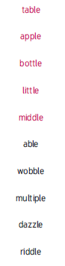 | 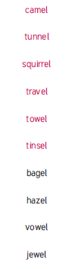 | 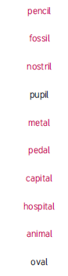 | 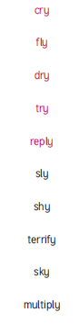
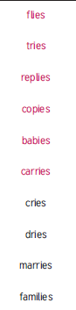 |  |  | 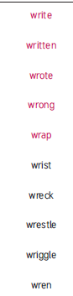
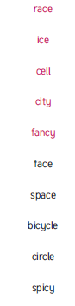 | 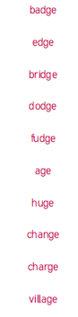 |  | 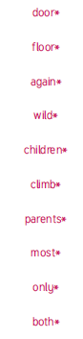
 | 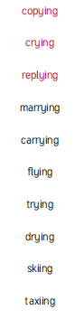 |  | 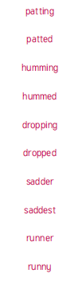
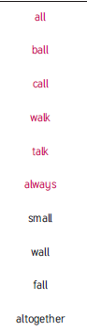 | 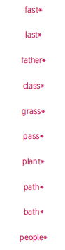 | 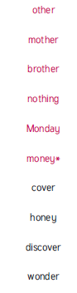
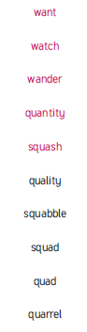 | 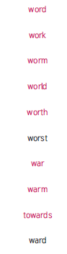 | 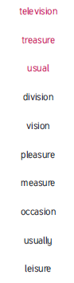 | 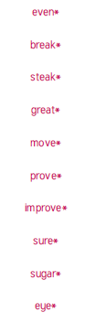
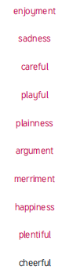 | 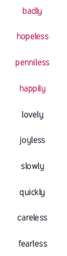 | 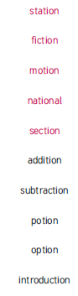 | 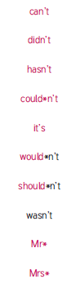
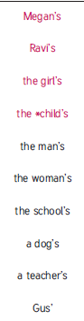 | 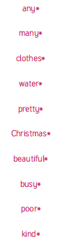 |  | 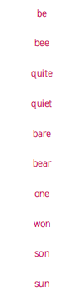
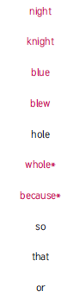 | 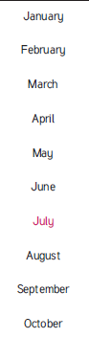 | 