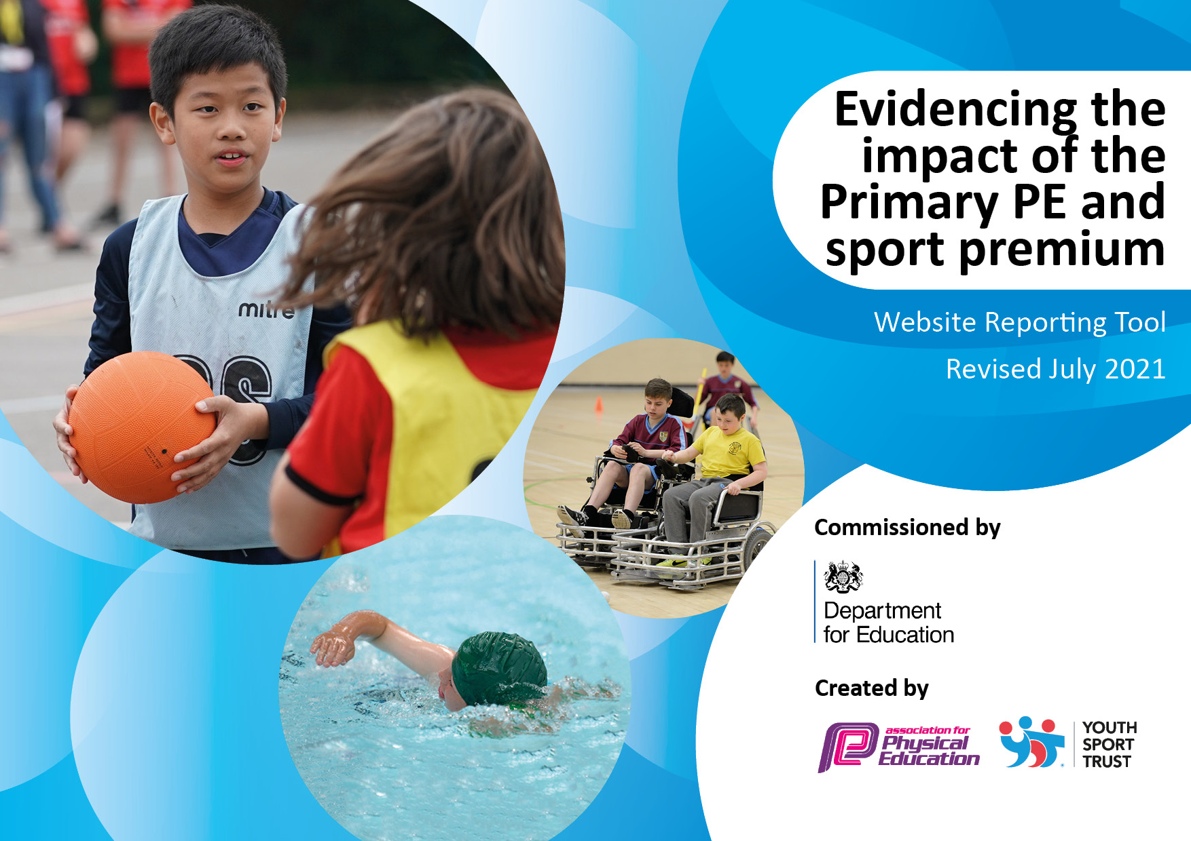
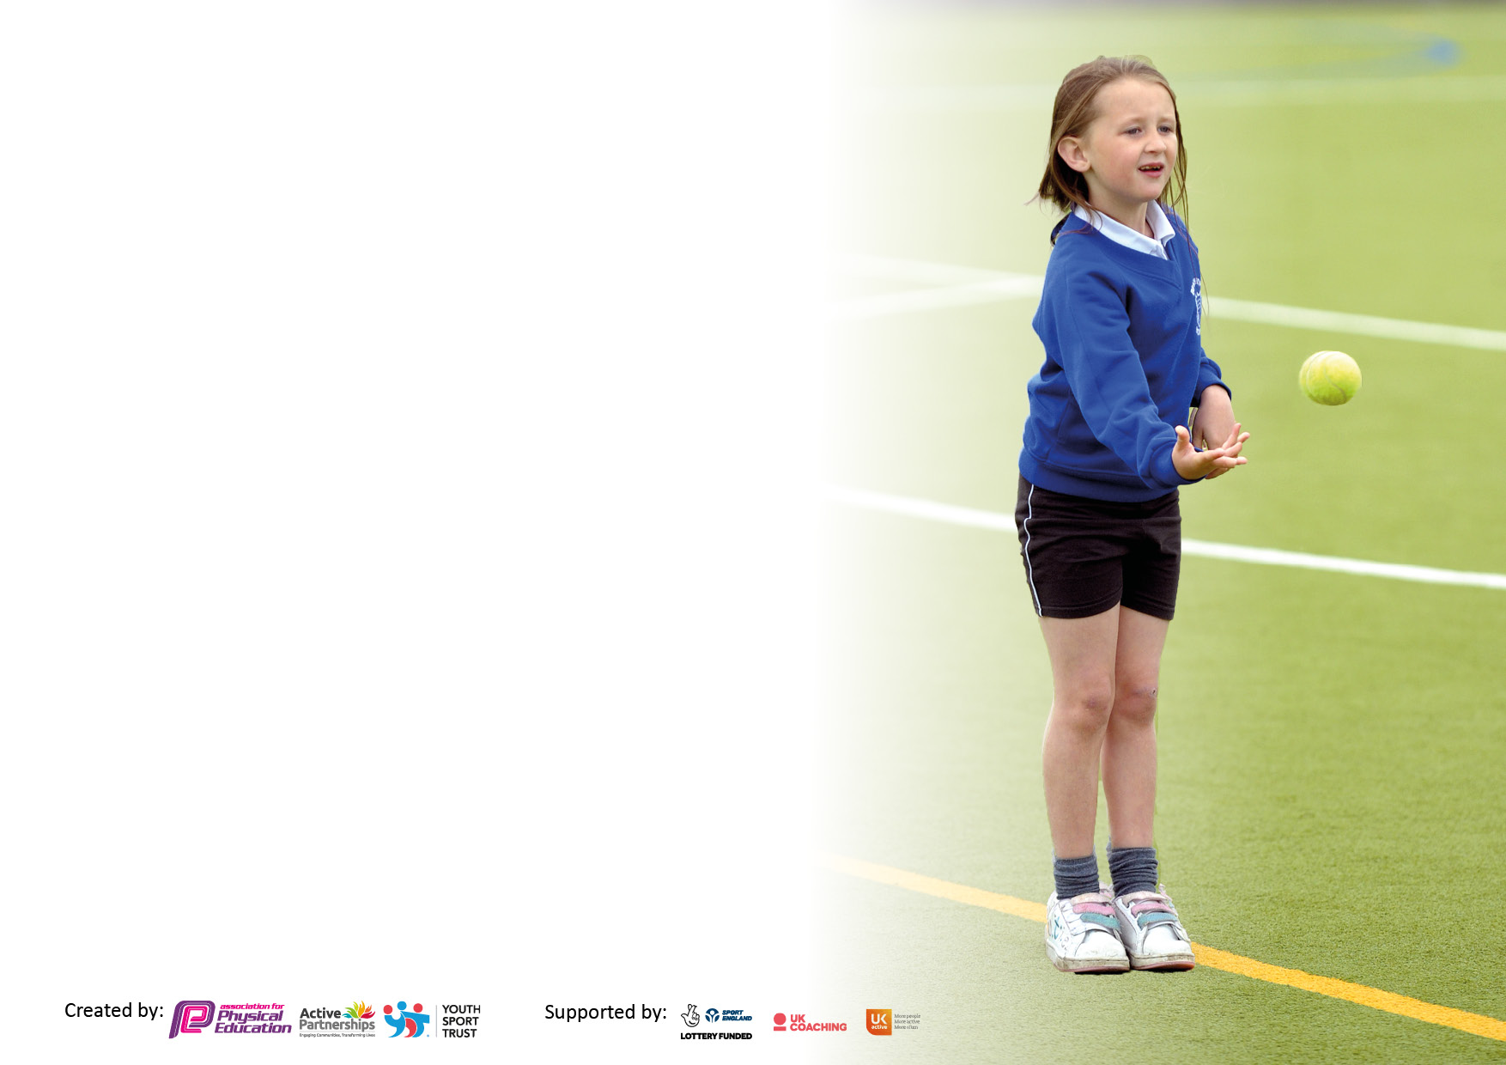

It is important that your grant is used effectively and based on school need. The Education Inspection Framework makes clear there will be a focus on ‘whether leaders and those responsible for governors all understand their respective roles and perform these in a way that enhances the effectiveness of the school’.

Under the Quality of Education Ofsted inspectors consider:
Intent - Curriculum design, coverage and appropriateness
Implementation - Curriculum delivery, Teaching (pedagogy) and Assessment
Impact - Attainment and progress

To assist schools with common transferable language this template has been developed to utilise the same three headings which should make your plans easily transferable between working documents.

Schools must use the funding to make additional and sustainable improvements to the quality of Physical Education, School Sport and Physical Activity (PESSPA) they offer. This means that you should use the Primary PE and sport premium to:

- Develop or add to the PESSPA activities that your school already offer
- Build capacity and capability within the school to ensure that improvements made now will benefit pupils joining the school in future years
- The Primary PE and sport premium should not be used to fund capital spend projects; the school’s budget should fund these.

Pleasevisitgov.ukfortherevisedDfEguidanceincludingthe5keyindicatorsacrosswhichschoolsshoulddemonstrate animprovement.Thisdocumentwillhelpyoutoreviewyourprovisionandtoreportyourspend.DfEencouragesschools to use this template as an effective way of meeting the reporting requirements of the Primary PE and sport premium.

We recommend you start by reflecting on the impact of current provision and reviewing the previous spend.

Schools are required to publish details of how they spend this funding, including any under-spend from 2019/2020, as well as on the impact it has on pupils’ PE and sport participation and attainment. All funding must be spent by 31st July 2022.

We recommend regularly updating the table and publishing it on your website throughout the year. This evidences your ongoing self-evaluation of how you are using the funding to secure maximum, sustainable impact. Final copy must be posted on your website by the end of the academic year and no later than the 31st July 2021. To see an example of how to complete the table please click HERE.

Details with regard to funding
Please complete the table below.

Total amount allocated for 2020/21 | £19,590
How much (if any) do you intend to carry over from this total fund into 2021/22? | £0
Total amount allocated for 2022/23 | £19,610
Total amount of funding for 2022/23. To be spent and reported on by 31st July 2023. | £19,610
Swimming Data
Please report on your Swimming Data below.

Meeting national curriculum requirements for swimming and water safety.

N.B. Complete this section to your best ability. For example, you might have practised safe self-rescue techniques on dry land which you can then transfer to the pool when school swimming restarts.
Due to exceptional circumstances priority should be given to ensuring that pupils can perform safe self-rescue even if they do not fully meet the first two requirements of the NC programme of study
What percentage of your current Year 6 cohort swim competently, confidently and proficiently over a distance of at least 25 metres?  N.B. Even though your pupils may swim in another year please report on their attainment on leaving primary school at the end of the summer term 2022.  Please see note above | 91%
What percentage of your current Year 6 cohort use a range of strokes effectively [for example, front crawl, backstroke and breaststroke]?  Please see note above | 91%
What percentage of your current Year 6 cohort perform safe self-rescue in different water-based situations? | 91%
Schools can choose to use the Primary PE and sport premium to provide additional provision for swimming, but this must be for activity over and above the national curriculum requirements. Have you used it in this way? | No

Action Plan and Budget Tracking
Capture your intended annual spend against the 5 key indicators. Clarify the success criteria and evidence of impact that you intend to measure to evaluate for pupils today and for the future.

Academic Year: 2021/22 | Total fund allocated: | Date Updated:
Key indicator 1: The engagement of all pupils in regular physical activity – Chief Medical Officers guidelines recommend that primary school pupils undertake at least 30 minutes of physical activity a day in school |  |  |  | Percentage of total allocation:
 |  |  |  | 59%
Intent | Implementation |  | Impact | £11,606
Your school focus should be clear what you want the pupils to know and be able to do and about  what they need to learn and to  consolidate through practice: | Make sure your actions to achieve are linked to your intentions: | Funding allocated: | Evidence of impact: what do pupils now know and what can they now do? What has changed? | Sustainability and suggested next steps:
- KS2 classes receive at least 2 hours of sports lessons per week to ensure regular physical activity  - Develop playtimes for KS1 and KS2 so that they are even more structured and inclusive for those who do not want to participate in sports or games  - Ensure a range of children take part in active lunchtimes. New children and vulnerable children to be given extra support to join in active games and activities.  - 100% pupils meet end of key stage 2 expectations of being able to swim 25m.  - Children assessed as less active are targeted for Change for Life Club and develop an awareness of what it means to have a healthier lifestyle and aware of health issues.  - Bikeability training ensures pupils are much better equipped for riding on today’s road. | - Ensure timetables reflect 2 hours of PE / sports coaching each week.  - To become an Opal School where KS1 and KS2 will partake in structured and creative activities to enable children to be active for the whole of playtime.  - Lunchtime staff to be trained as an Opal teacher and to set up, monitor and encourage pupils to be regularly active and try new activities.  - Seek extra swimming sessions in Spring or Summer terms for year 4/5 and 6 children. Minibuses used to transport to and from venue.  - Change for life club to be delivered to engage reluctant children to educate them on what is a healthy lifestyle, improve confidence, fitness levels and motivation to partake in PE/Sport.  - Engage pupils in Bikeability sessions. | £0  £5000  £3039  £1,500  £2067 | End of unit assessments from the new PE scheme to be completed and feedback from teachers show that children are engaging in PE lessons.  Photos and feedback from SLT, SENDCO and PE Lead to show that children are even more engaged in physical activity over a prolonged period.  Photos, feedback from children and observations from adults show that all children take part in activity.  Monitoring the number of children able to swim the 25m shows that children are swimmers before reaching year 6?  Photos and feedback from sports leaders and children.  Children are motivated to take part in PE/sport and living a healthier lifestyle?  Children better understand road safety and use cycling as a form of exercise. | Children are enjoying and engaging in at least 2 hours of PE each week. To continue this 2023-2024.  Ongoing: children are very engaged with den building, loose parts, mud kitchen and small parts. Lunch times are more structured, creative and active. Development of Opal is ongoing.  Lunchtimes are set up so that the support staff know the children that they are working with allowing the venerable children to gain the support and encouragement they need.  98% of pupils met the expectations of being able to swim 25m.  Children look forward to their change4life session and PE sessions. These children are becoming confident to involve themselves in sports afterschool clubs. To continue to identify those children who are less active and involve them in Chang4life.  There has been an influx of children who now ride to and from school on their bikes.
Key indicator 2: The profile of PESSPA being raised across the school as a tool for whole school improvement |  |  |  | Percentage of total allocation:
 |  |  |  | 0%
Intent | Implementation |  | Impact
Your school focus should be clear what you want the pupils to know and be able to do and about  what they need to learn and to  consolidate through practice: | Make sure your actions to achieve are linked to your intentions: | Funding allocated: | Evidence of impact: what do pupils now know and what can they now do? What has changed? | Sustainability and suggested next steps:
- Maintain a culture demonstrating the importance of PE and Sport and ensure it is embedded across the school. All children aspire to being involved in PE, sports and keeping active.  - Continue to develop the depth of personal achievement into the curriculum.  - Children have more opportunities to participate in a range of sporting activities lead by staff with specific skills and expertise in the sport.  - Signpost to local clubs encourage children to take part in new sports and activities. | - Achievements celebrated in assembly (match results + notable achievements in lessons etc.)  Achievements also to be celebrated via a new sports magazine which will be emailed out to class teachers (to share with children) parents and carers to celebrate the achievements from that term.  - Continue to promote the use of assessment (on iPads) to allow children to identify their personal achievements within a unit (e.g., indoor athletics). Use the daily mile to track activity levels and allow opportunity for personal achievement.  - Teaching staff to use their knowledge and skill to deliver and lead extra-curricular clubs.  - Advertise different clubs and activities in the school newsletter, on social media pages and in the termly sports magazine. | £0  £0  £0  £0 | The profile of PE and Sports is high within the school community.  Children can identify and improve their personal achievements.  Children are participating and experiencing a range of sports that they may not have before.  Families are better informed of opportunities across the borough.  Children can take part both individually for personal achievement and as part of their house colour as part of a larger team. | Children are continuing to aspire and are proud to be selected for sporting events and the school has entered the most events so far in 2022-2023 than it ever has, and we will continue to improve this. To continue to maintain the culture in the school.  Children are understanding the importance of setting themselves personal targets and strive to increase their target each time. To continue to develop this provision.  Children recognise the importance of setting themselves goals and personal achievements to strive to be better. Children record PB in some units of PE and the daily mile. To continue the PB setting with Skip2bfit.  Extra-curricular clubs are changed on a half termly basis to ensure engagement of a range of sports. Children experience sports that may not be in the PR curriculum.  PE staff have many local links to clubs which parents and carers are signposted to via email, social media and news letters.

Key indicator 3: Increased confidence, knowledge, and skills of all staff in teaching PE and sport |  |  |  | Percentage of total allocation:
 |  |  |  | 7%
Intent | Implementation |  | Impact | £1350
Your school focus should be clear | Make sure your actions to | Funding | Evidence of impact: what do | Sustainability and suggested
what you want the pupils to know | achieve are linked to your | allocated: | pupils now know and what | next steps:
and be able to do and about | intentions: |  | can they now do? What has
what they need to learn and to |  |  | changed?
consolidate through practice:
- Teachers to feel more confident and knowledgeable delivering PE and assessment.  - Continuing Professional Development to support teachers in their ability to teach engaging sports lessons.  - Children can identify with success and aspire to be a local sporting hero. | - New PE scheme to be used for all key stages to deliver their PE sessions to ensure confidence in assessment.  - Continue to plan opportunities for training for staff to take place during the school year.  Telford and Wrekin Sports Providers to offer CPD and mentoring to NQTs, New staff and other staff identified from a staff audit.  - Ascertain which local personalities the children relate to and invite them into school.  Focus on a Football in 2023. | £500  £500  £350 | Feedback from staff on teaching PE and Sport indicates they are more confident in the assessment of PE.  More inclusive lessons that challenge children at all levels.  Feedback from staff on teaching PE and Sport indicates they are more confident in delivery.  Through the successes of local sporting personalities - Children are inspired to participate and follow their dreams. | Teacher moral is still high using the new scheme and continued professional development is given to all staff on a rota basis either through the Telford and Wrekin partnership, PE coordinator or sports coaches. To continue the knowledge and confidence of assessment with teaching staff delivering PE. NQT’s have taken part in CPD in PE to increase confidence. The new PE scheme allows itself to be inclusive at all levels.  This event is a huge success, involving all children to be active and meet a local sporting personality. To arrange a different sporting personality to attend in 2023-2024.
Key indicator 4: Broader experience of a range of sports and activities offered to all pupils |  |  |  | Percentage of total allocation:
 |  |  |  | 33%
Intent | Implementation |  | Impact | £6460
Your school focus should be clear | Make sure your actions to | Funding | Evidence of impact: what do | Sustainability and suggested
what you want the pupils to know | achieve are linked to your | allocated: | pupils now know and what | next steps:
and be able to do and about | intentions: |  | can they now do? What has
what they need to learn and to |  |  | changed?
consolidate through practice:
Additional achievements:  - Children take part in a range of adventurous activities.  - Children able to participate in activities and sports with other schools.  - Children able to participate in new sports and physical activities (inclusive sports) | - To organise adventurous activities, either in school or visiting activity centres – Arthog.  - PE Lead and sports coach to organise competitions and practise games against other schools.  - PE Lead and sports coach to introduce new sports and physical activities such as OAA, Wallball and Quidditch. Source and purchase equipment to support provision and teaching of new sports and physical activities. | £360  £2600  £3500 | Activities taking place. Feedback from children and staff show these are received positively.  Children to become confident competing against other schools and develop teamwork and leadership skills.  A wider range of sports accessible by all. Children enjoy taking part in events. Photos, newsletter, website and feedback from children and adults. | Children were able to experience activities that they may not have experienced before, allowing them to become more confident and positive. To continue the link with Arthog.  2022-2023 has seen the school participate in an increase of sporting events competing against other schools. Children enjoy the competition and in turn have developed teamwork skills. Natural leaders have evolved and become sports ambassadors and Captains of the school. To maintain the level of event participation.  To introduce new sports such as Pickleball.
Key indicator 5: Increased participation in competitive sport |  |  |  | Percentage of total allocation:
 |  |  |  | 13%
Intent | Implementation |  | Impact | £2600
Your school focus should be clear | Make sure your actions to | Funding | Evidence of impact: what do | Sustainability and suggested
what you want the pupils to know | achieve are linked to your | allocated: | pupils now know and what | next steps:
and be able to do and about | intentions: |  | can they now do? What has
what they need to learn and to |  |  | changed?:
consolidate through practice:
- To maintain the participation in sports competitions through the membership of the Telford and Wrekin Sports Partnership.  - Increase interhouse competitions. | - Continue to encourage and ensure more children are representing the school in competition from inclusive to competitive sport.  Minibuses used to transport teams to and from sporting and competitive events  - PE lead and sports coach to organise competition at the end of each unit of PE.  To organise interhouse competitions each term. To use special events (Comic relief, world cup etc) to hold whole-school inter-house competitions. | £2600  School fund  £100 | More children celebrate participation in competitions.  More children celebrate participation in competitions. | 2022-2023 has seen the school participate in the most competitions so far.
Signed off by 2 |  | Subject Leader: | Bridgitte Jones
 |  | Date: | Sept 2022
Head Teacher: | C A Mcquiggin | Governor: | Kirsty Smallman
Date: | Sept 2022 | Date: | Sept 2022

