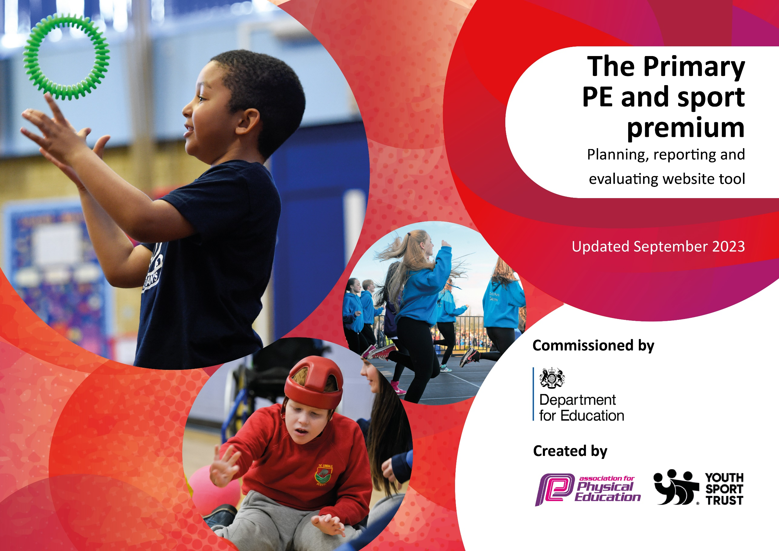

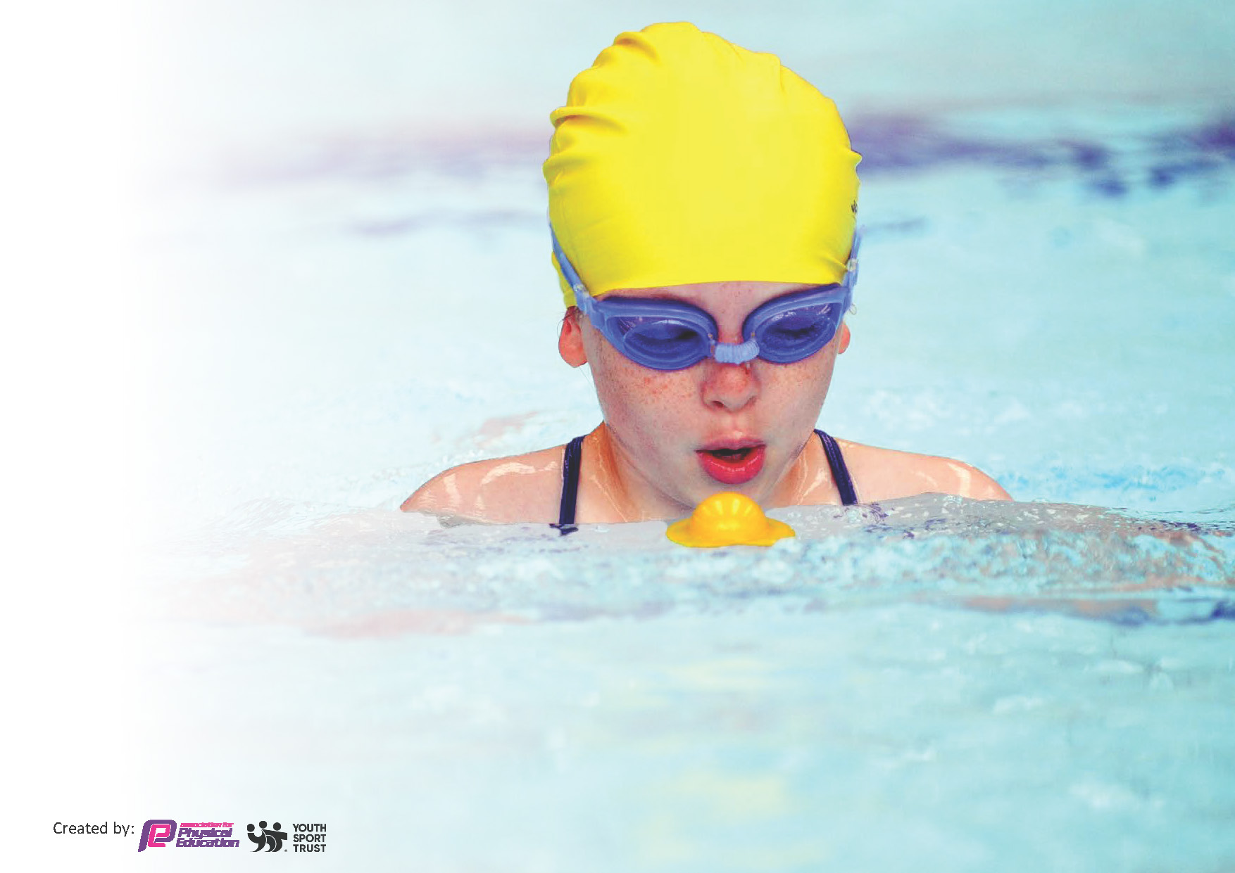
This template can be used for multiple purposes:
by:
- It enables schools to effectively plan their use of the Primary PE and sport premium
- It helps schools to meet the requirements (as set out in guidance) to publish information on their Primary PE and sport premium
- It will be an effective document to support Ofsted inspections enabling schools to evidence progress in Physical Education (PE) and evidence swimming attainment, which forms part of the PE National Curriculum. We would recommend schools consider
the Intent, Implementation and Impact of any spend, as examined within the Education Inspection Framework.

It is important that your grant is used effectively and based on school need.

Schools must use the funding to make additional and sustainable
improvements to the quality of the PE, School Sport and Physical Activity (PESSPA)
they offer. This means that you should use the Primary PE and sport premium to:

- Build capacity and capability within the school to ensure that improvements made now will benefit pupils joining the school in future years
- Develop or add to the PESSPA activities that your school already offers.

The Primary PE and sport premium should not be used to fund capital spend projects; the school’s core budget should fund these. Further detail on capital expenditure can be found in the updated Primary PE and sport premium guidance.

The Primary PE and sport premium guidance, outlines 5 key priorities that funding should be used towards. It is not

necessary that spending has to meet all the key priorities, you should select the priorities that you aim to use any funding towards.

Although completing this template is not a requirement for schools, schools are required to publish details of how they spend this funding. Schools must also outline what the impact this funding has had on pupils’ PE and sport participation and attainment and how any spending will be sustainable in the future. All funding must be spent by 31st July 2024.

The Department for Education has worked closely with the Association for Physical Education (afPE) and the Youth Sport Trust (YST) to develop this template and encourages schools to use it. This template is an effective way of meeting the reporting requirements of the Primary PE and sport premium.
Review of last year’s spend and key achievements (2022/2023)

We recommend you start by reflecting on the impact of current provision and reviewing your previous spend.

Activity/Action | Impact | Comments
See last year’s document for review.

Key priorities and Planning

Action – what are you planning to do | Who does this action impact? | Key indicator to meet | Impacts and how sustainability will be achieved? | Cost linked to the action
- KS2 classes receive at least 2 hours of sports lessons per week to ensure regular physical activity.  - To continue to develop playtimes for KS1 and KS2 so that they are even more structured and inclusive, especially for those who do not want to participate in sports or games.  - Continued training for staff on becoming an ‘Opal School’  - Seek extra swimming sessions in Spring or Summer terms for year 5 and 6 children. Minibuses used to transport to and from venue.  - Change for life club to be delivered to engage reluctant children to educate them on what is a healthy lifestyle, improve confidence, fitness levels and motivation to partake in PE/Sport.  - Engage pupils in Bikeability sessions.  - Teachers continue to feel more confident and knowledgeable delivering PE and assessment.  - Continuing Professional Development to support teachers in their ability to teach engaging sports lessons.  - Children can identify with success and aspire to be a local sporting hero.  - Maintain a culture demonstrating the importance of PE and Sport and ensure it is embedded across the school. All children aspire to being involved in PE, sports and keeping active.  - Continue to develop the depth of personal achievement into the curriculum.  - Children have more opportunities to participate in a range of sporting activities lead by staff with specific skills and expertise in the sport.  - Signpost to local clubs encourage children to take part in new sports and activities.  - Children take part in a range of adventurous activities.  - Children to participate in activities and sports with other schools.  - Children able to participate in new sports and physical activities (inclusive sports).  - To maintain the participation in sports competitions through the membership of the Telford and Wrekin Sports Partnership.  - Increase interhouse competitions.  - To ensure SEND and PP children have the same opportunities to access PE and sport competitions.  - To enter as many team competitions as possible allowing Lawley children to apply their skills competitive fixtures. | Pupils and teachers.  Pupils, TA’s, lunch time staff, Opal Team, SLT.  TA’s, lunch time staff, Opal Team, SLT.  Pupils and Teachers.  Sports coaches and pupils.  Pupils.  Teachers, sports coach and pupils  Teachers, sports coaches and pupils.  Pupils  Teachers, sports coaches, SLT and pupils.  Teachers, sports coaches and pupils.  Teachers, sports coaches and pupils.  PE lead, sports coach, parents and pupils.  Sports coaches and pupils.  PE lead, sports coach and pupils.  PE Lead, sports coach and pupils.  PE Lead.  PE Lead and sports coach.  PE Lead, TA’s and sports coach.  PE Lead , TA’s and sports coach. | Key indicator 2: The engagement of all pupils in regular physical activity.  Key indicator 4: Broader experience of a range of sports and activities offered to all pupils.  Key indicator 2: The engagement of all pupils in regular physical activity.  Key indicator 4: Broader experience of a range of sports and activities offered to all pupils.  Key indicator 2: The engagement of all pupils in regular physical activity.  Key indicator 2: The engagement of all pupils in regular physical activity.  Key indicator 2: The engagement of all pupils in regular physical activity.  Key indicator 2: The engagement of all pupils in regular physical activity.  Key indicator 1: Increased confidence, knowledge and skills of all staff in teaching PE and sport.  Key indicator 2: The engagement of all pupils in regular physical activity.  Key indicator 3: The profile of PE and sport is raised across the school as a tool for whole-school improvement.  Key indicator 4: Broader experience of a range of sports and activities offered to all pupils.  Key indicator 1: Increased confidence, knowledge and skills of all staff in teaching PE and sport.  Key indicator 2: The engagement of all pupils in regular physical activity.  Key indicator 2: The engagement of all pupils in regular physical activity.  Key indicator 3: The profile of PE and sport is raised across the school as a tool for whole-school improvement.  Key indicator 3: The profile of PE and sport is raised across the school as a tool for whole-school improvement.  Key indicator 2: The engagement of all pupils in regular physical activity.  Key indicator 3: The profile of PE and sport is raised across the school as a tool for whole-school improvement.  Key indicator 3: The profile of PE and sport is raised across the school as a tool for whole-school improvement.  Key indicator 3: The profile of PE and sport is raised across the school as a tool for whole-school improvement.  Key indicator 4: Broader experience of a range of sports and activities offered to all pupils.  Key indicator 4: Broader experience of a range of sports and activities offered to all pupils.  Key indicator 4: Broader experience of a range of sports and activities offered to all pupils.  Key indicator 5: Increased participation in competitive sport.  Key indicator 5: Increased participation in competitive sport.  Key indicator 4: Broader experience of a range of sports and activities offered to all pupils.  Key indicator 4: Broader experience of a range of sports and activities offered to all pupils  Key indicator 5: Increased participation in competitive sport. | More pupils meeting their daily physical activity goal, more pupils encouraged to take part in PE and Sport Activities.  Photos and feedback from SLT, SENDCO and PE Lead to show that children are even more engaged in physical activity over a prolonged period.  Photos, feedback from children and observations from adults show that all children take part in activity.  Monitoring the number of children able to swim the 25m shows that children are swimmers before reaching year 6?  Children to participate in pupil voice with a view to seeing an increase in motivation to partake in sports in and out of school and an understanding of a healthier lifestyle.  Children understand road safety and use cycling as a form of exercise.  PE scheme to be used again this year for all key stages to deliver their PE sessions to ensure confidence in assessment.  Continue to plan opportunities for training for staff to take place during the school year.  Continue CPD for ECT and staff with Telford and Wrekin Partnership.  Ascertain which local personalities the children relate to and invite them into school.  Achievements celebrated in assembly (match results + notable achievements in lessons etc.)  Continue to promote the use of assessment (on iPads) to allow children to identify their personal achievements within a unit (e.g., Fitness unit). Use the daily mile and Skip2Bfit to track activity levels and allow opportunity for personal achievement.  Children are participating and experiencing a range of sports that they may not have before.  Teaching staff to use their knowledge and skill to deliver and lead extra-curricular clubs.  Advertise different clubs and activities in the school newsletter, on social media pages and in the termly sports magazine.  To organise adventurous activities, either in school or visiting activity centres – Arthog.  PE Lead and sports coach to organise competitions and practise games against other schools.  PE Lead and sports coach to continue to introduce new sports and physical activities. Source and purchase equipment to support provision and teaching of new sports and physical activities.  Continue to encourage and ensure more children are representing the school in competition from inclusive to competitive sport.  To organise interhouse competitions each term at the end of each unit. To use special events (Comic relief, world cup etc) to hold whole-school inter-house competitions.  To enter as many inclusive competitions within the sports partnership as possible and update PE equipment.  Minibuses used to transport teams to and from sporting and competitive events.  New kit to be bought for teams representing Lawley Primary School. | Planned through curriculum  £3,000  £2,000  £1,500  £2,067  £96  £500  £500  £350  £100  £0  £0  £0  £360  £2,600  £3,500  £2,600  £200  £2,500  £6,000

Key achievements 2023-2024

Activity/Action | Impact | Comments

Swimming Data
Meeting National Curriculum requirements for swimming and water safety.
Priority should always be given to ensuring that pupils can perform safe self-rescue even if they do not fully meet the first two requirements of the National Curriculum programme of study

Question | Stats: | Further context  Relative to local challenges
What percentage of your current Year 6 cohort can swim competently, confidently and proficiently over a distance of at least 25 metres? | % | Use this text box to give further context behind the percentage.  e.g., 30% - we are struggling to get pool space due to our local pool closing so we have had to use a much smaller local school pool. We have had to limit the number of pupils attending swimming lessons during one term which means some pupils have attended fewer swimming lessons than others.
What percentage of your current Year 6 cohort can use a range of strokes effectively [for example, front crawl, backstroke, and breaststroke]? | % | Use this text box to give further context behind the percentage.  e.g., Even though your pupils may swim in another year please report on their attainment on leaving primary school at the end of the summer term 2024

What percentage of your current Year 6 cohort are able to perform safe self-rescue in different water-based situations? | % | Use this text box to give further context behind the percentage.
If your schools swimming data is below national expectation, you can choose to use the Primary PE and sport premium to provide additional top-up sessions for those pupils that did not meet National Curriculum  requirements after the completion of core lessons. Have you done this? | Yes/No
Have you provided CPD to improve the knowledge and confidence of staff to be able to teach swimming and water safety? | Yes/No

Signed off by:

Head Teacher: | Carol Mcquiggin
Subject Leader or the individual responsible for the Primary PE and sport premium: | Bridgitte Jones PE Lead
Governor: | Emma Oates
Date: | 15/03/2024
Key indicator 1: Increased confidence, knowledge, and skills of all staff in teaching PE and sport.
Key indicator 2: The engagement of all pupils in regular physical activity.
Key indicator 3: The profile of PE and sport is raised across the school as a tool for whole-school improvement.
Key indicator 4: Broader experience of a range of sports and activities offered to all pupils.
Key indicator 5: Increased participation in competitive sport.

