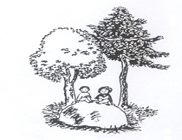
Year 2 Lawley Primary School Spring 1

 | Monday | Tuesday | Wednesday | Thursday | Friday
AM 1  9:00 – 9:30am | Maths | Maths | Science | Maths | Maths
9:30 – 10:25am  10:25 – 10:45am | Guided Reading | Guided Reading | Guided reading | Guided Reading | Guided Reading
 | Assembly - BLP | Assembly - JOP
10.25–11.00
AM 2 | English – | English – | History | English - | English –
12:05 -1:05
PM 1  1:00 – 1:35 | Phonics | PPA  Spanish  PE | Phonics | Phonics | Phonics
PM 2  1:35 – 2:45 | Maths Arithmetic |  | Art | RHE – Health and Well Being  P.E | RE – Islam
PM 3 | Class Story |  | Class story | Class Story | Class Story

