Pupil premium strategy statement Lawley Primary School
This statement details our school’s use of pupil premium (and recovery premium) funding to help improve the attainment of our disadvantaged pupils.
It outlines our pupil premium strategy, how we intend to spend the funding in this academic year and the outcomes for disadvantaged pupils last academic year.

School overview
Detail | Data
Number of pupils in school | 421
Proportion (%) of pupil premium eligible pupils | 11%
Academic year/years that our current pupil premium strategy plan covers (3 year plans are recommended) | 2023-2024  2024-2025 review  2025-2026
Date this statement was published | December 2023  (Reviewed Dec 2024)  (Reviewed Dec 2025)
Date on which it will be reviewed | December 2026
Statement authorised by | Carol Mcquiggin
Pupil premium lead | Carol Mcquiggin
Governor / Trustee lead | Kate Kneller

Funding overview
Detail | Amount
Pupil premium funding allocation this academic year | £66,065
Recovery premium funding allocation this academic year | £5,220
Pupil premium (and recovery premium*) funding carried forward from previous years (enter £0 if not applicable)  *Recovery premium received in academic year 2021 to 2022 can be carried forward to academic year 2022 to 2023. Recovery premium received in academic year 2022 to 2023 cannot be carried forward to 2023 to 2024. | £0
Total budget for this academic year  If your school is an academy in a trust that pools this funding, state the amount available to your school this academic year | £71,285

Part A: Pupil premium strategy plan

Statement of intent
We aim to prioritise our most disadvantaged pupils, through high-quality teaching and targeted support and intervention where needed and provide them with the skills they need to be resilient, adaptable, and equipped to deal with whatever challenges our rapidly changing world may hold for them
To continue to ensure the outcomes for pupils in receipt of pupil premium are at least in line with those of peers in school across the curriculum.
Almost 20% of our pupils in receipt of pupil premium have identified special educational needs and a number have been, or are, under the care of the Local Authority. In all cases we strive to ensure all our pupils make excellent progress. We believe that all our pupils benefit from high quality teaching every day and we ensure our strategy provides for this with further additional intervention through one to one and small group teaching. We have accessed this using our current staff in school but also accessing training through the National Tutoring Programme.
We have recently identified a small group of pupils who are not making the progress we would expect, despite specific intervention, and so our strategy for 2023-2025 focuses on the needs of this group. Our SLT work to ensure high aspiration and high-quality provision for all pupils in receipt of pupil premium.
Ensure the well-being needs of all pupils in receipt of pupil premium funding are met to ensure they are on track to make or exceed expected progress and attainment.
We intend to provide opportunities for children to develop as independent, confident, and successful learners with high aspirations, who know how to make a positive contribution to their community and wider society. This has been particularly evident for children on entry to EYFS. We have established a successful induction programme which is now embedded in school and a weekly Forest School session for our youngest children. EYFS also have their own Emotional Literacy Support teacher early intervention helps to remove these barriers sooner in the child’s education. Lockdown has seen an increase in pupils’ emotional and social needs that impact on learning with increases in both pupil and adult mental health and wellbeing needs. Our strategy includes a highly experienced Pupil and Family Support Officer in school. She works with our team, with external professionals and with our pupils and families directly.

Challenges
This details the key challenges to achievement that we have identified among our disadvantaged pupils.
Challenge number | Detail of challenge
1 | Our pupil premium children as a group are not making as rapid progress as non-pupil premium children.
2 | The attainment of our pupil premium children is lower than that of non-pupil premium children at the end of KS2.
3 | 20% coupled vulnerability having an additional special educational need, behaviour or attachment and trauma.
4 | Many of our pupil premium children do not have the rich and varied experiences as non-pupil premium children seem to have meaning knowledge of the world and vocabulary acquisition is limited.
5 | Many of our pupil premium children require emotional health and well-being support due to difficulties outside school that then impact on their progress and attainment in school.

Intended outcomes
This explains the outcomes we are aiming for by the end of our current strategy plan, and how we will measure whether they have been achieved.
Intended outcome | Success criteria
Improved oral language skills and vocabulary among disadvantaged pupils. | Speech and language will improve across the year and children will have a better understanding of vocabulary. Assessments and observations indicate significantly improved oral language among disadvantaged pupils. This is evident when triangulated with other sources of evidence, including engagement in lessons, book scrutiny and ongoing formative assessment.
Improved reading, writing and maths attainment among disadvantaged pupils. | KS2 reading, writing and maths outcomes in 2023/24 will show that the % of disadvantaged pupils meeting the combined expected standard is at National level.
To achieve and sustain improved wellbeing for all pupils in our school, particularly our disadvantaged pupils. | Sustained high levels of wellbeing by 2024/25 demonstrated by:  - qualitative data from pupil voice, and parent surveys and teacher observations  - a significant increase in participation in enrichment activities, particularly among disadvantaged pupils

Activity in this academic year
This details how we intend to spend our pupil premium (and recovery premium) funding this academic year to address the challenges listed above.

Teaching (for example, CPD, recruitment and retention)
Budgeted cost: £ 17,087
Activity | Evidence that supports this approach | Challenge number(s) addressed
Purchase of standardised and diagnostic assessments.  Training for staff to ensure assessments are interpreted and administered correctly. | A range of diagnostic tests provide reliable insights into the specific strengths and weaknesses of each pupil to help ensure they receive the correct.  https://educationendowmentfoundation.org.uk/education-evidence/guidance-reports/effective-professional-development | 1,2,3
Purchase of further reading materials to support our DfE validated Systematic Synthetic Phonics programme to secure stronger phonics teaching for all pupils.  All relevant staff (including new staff) receive training and support in the effective delivery of the phonics scheme. Phonics is well- resourced and prioritised in EYFS and KS1. | Phonics approaches have a strong evidence base that indicates a positive impact on the accuracy of word reading (though not necessarily comprehension), particularly for disadvantaged pupils.  A secure and consistent approach to the teaching of phonics, particularly in KS2 for targeted pupils, will provide children with the skills they need to de-code and achieve improved progress and attainment in reading.  https://educationendowmentfoundation.org.uk/education-evidence/evidence-reviews | 1,2
TAs high quality CPD repeated to ensure they can consistently model and scaffold strategies and select reading books that are correctly matched to ability level. | The reading attainment of target pupils and those in DADV/SEND groups improve.  TAs will deliver effective intervention resulting in targeted pupils hey can consistently model and scaffold strategies.  https://educationendowmentfoundation.org.uk/education-evidence/guidance-reports/effective-professional-development | 1,2
Resource and implement new progression maps developed with clear, small steps for consolidation, new learning, and arithmetic.  Teachers are supported with CPD and coaching to implement mastery in maths in EYFS and KS1 to strengthen pupil fluency, to implement Number- sense in Y3 and 4 to strengthen pupil fluency.  And Arithmetic focus in Years 4 and 6 using detailed progression maps with weekly assessment data to strengthen pupil fluency. | Attainment in Maths at the end of KS2 will improve.  Attainment in Maths at the end of Y4 will improve.  Pupils will show good progress in their mastery of arithmetic.  https://educationendowmentfoundation.org.uk/education-evidence/evidence-reviews/mathematics-in-key-stages-2-and-3 | 1,2
CPI training refresher | CPI Safety Intervention incorporates trauma-informed and person-centred approaches. The programme is the perfect solution for professionals working in health, social care and education who need to prevent and/or intervene in crisis situations.  https://educationendowmentfoundation.org.uk/education-evidence/guidance-reports/behaviour | 3

Targeted academic support (for example, tutoring, one-to-one support, structured interventions)
Budgeted cost: £32,224
Activity | Evidence that supports this approach | Challenge number(s) addressed
An additional key person across the reception classes to increase the staff /child ratios to develop speaking and listening skills.  £15,624  Employment of a Speech and Language Support assistant to undertake duties and the implementation of Speech and Language Therapy (SLT) treatment plans for pupils and assessments under the direction of a qualified Speech and Language Therapist. | Communication and language approaches emphasise the importance of spoken language and verbal interaction for young children. They are based on the idea that children’s language development benefits from approaches that explicitly support communication through talking, verbal expression, modelling language and reasoning. On average, children who are involved in communication and language approaches make approximately +6 months additional progress over the course of a year. | 1,2,3,4
Parental engagement across School and in the Early Years  Showbie | Actively involving parents in supporting their children’s learning and development. Strategies include: approaches that encourage parents to read and talk with their children at home or to participate in activities in the early years setting; programmes that focus directly on parents themselves, for example, providing training in parenting skills or adult numeracy and literacy support; and more intensive programmes for disadvantaged families or families in crisis, for example through schools appointing a family liaison that work with parents through either home visits or other targeted approaches. On average, parental engagement programmes evaluated to date have led to a positive impact of approximately +4 months progress over the course of a year.
Extending School time  Homework club Y5&6  Mathematics Times Table club Y4 &5  Mathematics Year 6 club | Extending school time involved increasing learning time in schools during the school day. Programmes that extend school time have a positive impact on average but are expensive. Planning to get the most from any extra time is important. It should meet pupil’s needs and build on their capabilities. The average impact of approaches involving extending school time is about +3months progress over the course of the year.  Homework activities vary significantly, particularly between younger and older pupils, including but not limited to home reading activities, longer projects or essays and more directed and focussed work such as revision for tests. Homework has a positive impact on average +5 months.

Wider strategies (for example, related to attendance, behaviour, wellbeing)
Budgeted cost: £32,705
Activity | Evidence that supports this approach | Challenge number(s) addressed
Continued employment of Pupil & Family Support Officer in providing support and guidance for pupils and families in need of emotional health & wellbeing assistance.  Ensure PFSO and support worker have ongoing, sufficient training and supervision. | Support for disadvantaged pupils and families with emotional and mental health & wellbeing difficulties and addressing their needs so that pupils can focus on readiness to learn for the most disadvantaged pupils.  https://educationendowmentfoundation.org.uk/education-evidence/guidance-reports/primary-sel | 5
Purchase of Primary Outdoor Play and Learning (OPAL) Programme to sustainably improve the quality of play.  Training for all staff with regular follow-up meetings and further training. Purchase and replenishment of equipment. | Develop lunchtime activities to ensure that all pupils are engaged and included and to prevent playground issues.  Pupil premium pupils have opportunities to engage in activities and are supported in developing social skills through these.  https://outdoorplayandlearning.org.uk/rese arch-and-evidence/ | 4,5
All pupil premium children have access to after school clubs and school-time activities, including residential and day trips, designed to help develop social skills and team building. | Pupils build practical and life skills, improve self-confidence, and raise expectations of achievement. They have the same enrichment opportunities as non- pupil premium children.  https://educationendowmentfoundation.org .uk/guidance-for-teachers/life-skills- enrichment | 4

Total budgeted cost: £ £82,016

Part B: Review of the previous academic year

Outcomes for disadvantaged pupils
Review: 2024 - 2025
Challenges 1&2: Our pupil premium children as a group are not making as rapid progress as non-pupil premium children.
The attainment of our pupil premium children is lower than that of non-pupil premium children at the end of KS2.
Intended outcome: Improved reading, writing and maths attainment among disadvantaged pupils.
Last year, the new progression documents for maths, alongside the support of White Rose planning and assessment tools, continued to support monitoring and identification of gaps for pupils. Mastering number and number sense were embedded in KS1 and KS2, with regular assessment to ensure the commitment of facts to memory.
Pathways to writing was introduced in September 2024 and is now implemented across KS1 and KS2, with the English lead supporting all year groups in their planning and implementation of this programme. The scheme is a structured, mastery-based writing curriculum that is designed to support our pupils’ progress through progressive skill development, consistent practice and purposeful assessment. Our pupils now go on a gradual journey through ‘Gateway’ lessons that hook them into their new topic area, build vocabulary, discuss context and set the purpose/audience. They then access ‘Pathway’ lessons, which provide active skill development through modelled examples and scaffolding, blending short and extended writing tasks. Finally, they access ‘Writeaway’ – independent extended writing where pupils plan, draft, edit and publish a final piece that integrates their newly acquired skills. The impact of introducing ‘Pathways to writing’ has resulted in an improved, appropriate and consistent pitch across all year groups and we are seeing improved outcomes during our internal moderation of books. This scheme will continue to develop over the next year.
To support the English lessons and continue to develop and refine our adaptive teaching cycle, one year group explored the use of Widgit and AI in English lessons for a term before presenting their findings and impact to the rest of the school. Teachers founds that this support resulted in high level vocabulary being used in writing and a better quality of writing at length, particularly for PPG pupils.
Now, the whole school is exploring the use of these tools to enhance practice and support the progress of our vulnerable learners.
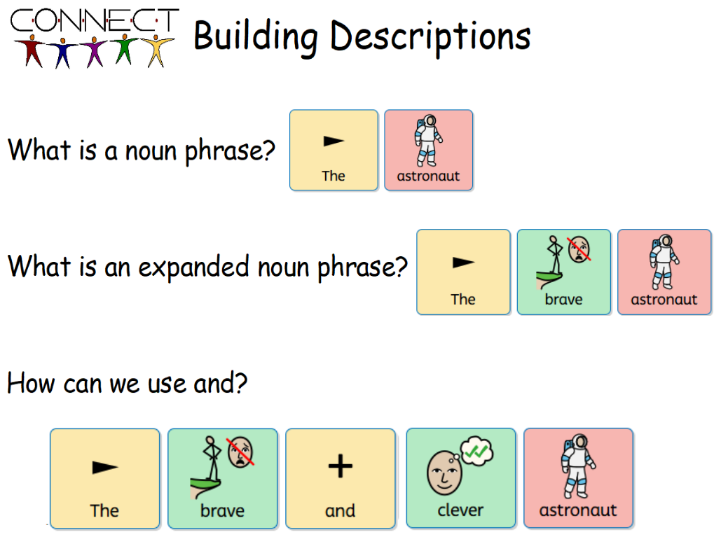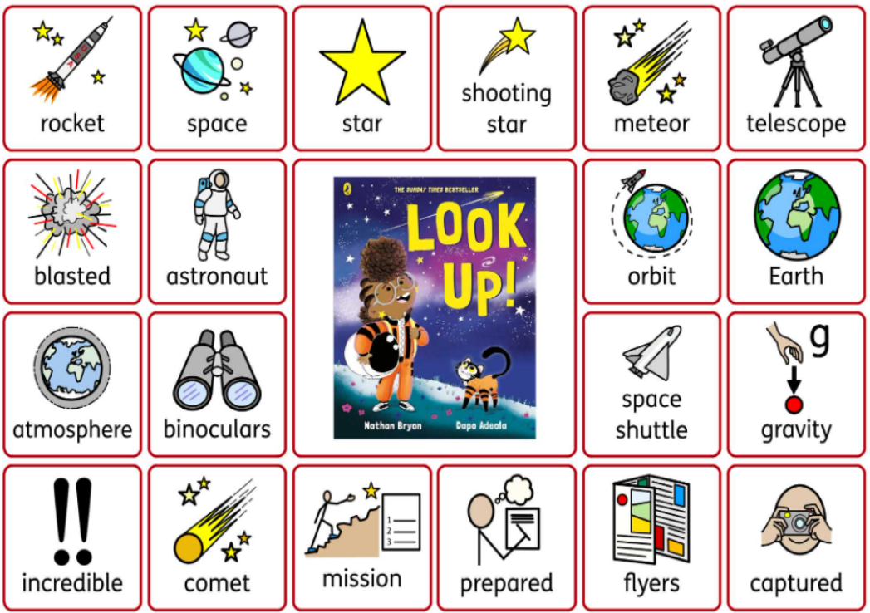
Widgit – support understanding and vocabulary Specific AI images created to support understanding
To specifically support our spelling and handwriting across the school, our daily timetable was changed from September 2024 to allow for an additional 30-minute learning time in the morning rather than the afternoon. During this time, we introduced a 15-minute spelling teach and 15 minutes daily handwriting following the Penpals handwriting programme. School book monitoring demonstrated good progress in handwriting presentation.
After school tutoring was provided to 21% of PPG pupils from year 2 – year 6 to support closing gaps and target arithmetic facts during 2024 - 2025. After school phonics was also provided for year 1 pupils and pupils in year 2 that did not meet the required standard for the phonics screening test, with good progress demonstrated from the previous year.
Progress in phonics data:
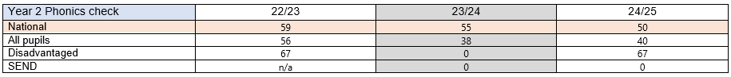
Data:
Data from internal tests and teacher assessments alongside statutory testing suggest that, despite some strong individual performances, the progress and attainment of the school’s disadvantaged pupils is still below National outcomes.
Current Update: 2025 Summer data
Attainment year 6
2024 - 2025
 |  | Below |  |  | At and Above |  |  | Above
 | No pupils | Maths | Reading | Writing | Maths | Reading | Writing | Maths | Reading | Writing
Year 6 | 60 | 25% | 21% | 32% | 75% | 79%  (SATs) | 68% | 24% | 37% (SATs) | 24%
Attainment of year 6 PPG pupils: attainment remains lower than national.
2024 – 2025
 |  | Below |  |  | At and Above |  |  | Above
 | No pupils | Maths | Reading | Writing | Maths | Reading | Writing | Maths | Reading | Writing
Year 6 |  |  |  |  | 64% | 64% | 45% | 18% | 27% | 27%

End of year data 2024 – 2025
Disadvantaged All Pupils
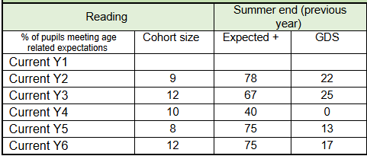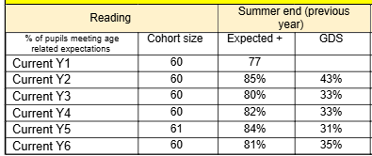
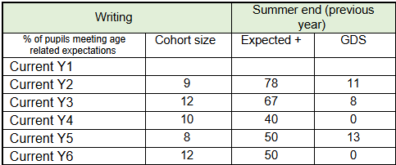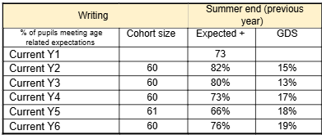
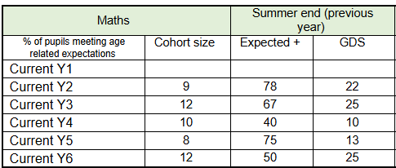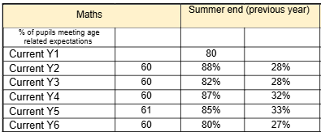
Challenge 3: 20% coupled vulnerability having an additional special educational need, behaviour or attachment and trauma.
Intended outcomes: Improved reading, writing and maths attainment among disadvantaged pupils.
To achieve and sustain improved wellbeing for all pupils in our school, particularly our disadvantaged pupils.
End of year data 2024 – 2025
22% of PPG pupils had SEND at the end of 2024/2025 (17 pupils out of 78)
35% of these SEND pupils have an EHCP (6 pupils). An additional 2 EHCNAs were requested and granted at the end of the academic year 2024 – 2025 to support 2 pupils moving to secondary (one Shropshire LA and one T&W).
In 2024 – 2025, 4 PPG/SEND pupils in receipt of an EHCP accessed an additional SEND provision two afternoons a week, led by the SENDCo and supported by the school’s educational psychologist. This provision focussed on supporting language, communication and social interaction, using EHCP targets and targets from the Liverpool Social communication journal. Using VERPs (video enhanced reflective practice) with our educational psychologist, we demonstrated positive progress in social and functional communication of our target pupils. We aim to continue to enhance this provision over the following year.
Additional focus was provided to support more vulnerable PPG pupils with SEND, as a lunchtime support group was created, focussing on structured activities and clear modelling from adults to support social development (4 PPG/SEND pupils accessed).
End of year attainment for PPG pupils with SEND
 | At and above
 | Reading | Writing | Maths
PPG/SEND pupils (17) | 5  (29.4%) | 1  (5.8%) | 4  (24%)
“The school establishes clear expectations for pupils’ behaviour from the early years onwards. They have recently placed a renewed emphasis on recognising good behaviour. The school is a calm and orderly place. Disruption to learning is rare, in part because pupils are keen to learn and enjoy what they do. Pupils are proud of their school and take care over their work.” (Ofsted September 2023)
“The school has high expectations for pupils, including pupils with special educational needs and/or disabilities (SEND), and staff alike.” (Ofsted September 2023)
“The school is quick to identify the needs of pupils with SEND. Staff are trained well to support them, and, overall, pupils with SEND learn well.” (Ofsted September 2023)

Challenge 4: Many of our pupil premium children do not have the rich and varied experiences as non-pupil premium children seem to have meaning knowledge of the world and vocabulary acquisition is limited.
Intended outcomes: Improved oral language skills and vocabulary among disadvantaged pupils.
To achieve and sustain improved wellbeing for all pupils in our school, particularly our disadvantaged pupils.
Rich and varied experiences:
“Visitors and trips out of school help pupils to engage with their learning. A well- planned programme of residential visits contributes to developing pupils’ character. Pupils have opportunities to take up positions of responsibility and to influence how the school runs.” (Ofsted September 2023)
All pupils are encouraged and supported to attend residential trips and activities. During 2024 – 2025, residential trips ran in years 4, 5 and 6 and year 5 attended Young Voices. All year groups went on trips to complement their learning in lessons. Telford music service provided live musical performances for all pupils to enjoy, and Rocksteady performed for a variety of year groups. During 2024 – 2025, 3 PPG pupils were supported to access Rock Steady. All children had the opportunity to visit the cinema and visits to the Exotic Zoo, Think Tank and an Egyptian Day were supported. Picture News was also purchased for use across the school to encourage our pupils to think critically, explore ‘big questions’, enhance their vocabulary and build safe exposure to current events to support their global and cultural awareness whilst reinforcing British Values and citizenship, alongside their moral, spiritual, social and cultural development.
After school clubs continued to be offered, with a focus on providing and funding places for PPG pupils. During 2023 – 2024, 52 PPG pupils accessed an after-school club. This year, 67 PPG pupils accessed an after-school club (86%). Of the 11 pupils who did not attend an organised after school club, 2 stayed for the wrap around after school care, and an additional 2 pupils accessed the free breakfast club that was offered to all pupils during a trial in the summer term. Our free breakfast club is now available to all pupils (from Sept 2025).
We continue our journey with OPAL as we develop lunchtime activities to ensure that all pupils are engaged and included as we devise areas and activities that support different types of play. To facilitate this, staff engaged in training with our OPAL mentor and Tas now support 30 minutes of lunchtime. Activities available to pupils include den building, loose parts exploration, a digging pit, outdoor gym, supported sports, arts/craft, quiet zones, mud kitchens, small world play, water play. Children also access a large sandpit that was constructed over the summer of 2025.
“At social times, they make good use of a wide range of playground equipment.” (Ofsted September 2023)
Language acquisition:
Language acquisition continues to be an important part of our daily lessons, and we have placed emphasis on this within our lesson delivery. Key vocabulary and topic vocabulary is highlighted within the learning and often supported by visuals to aid all learners. The online Widgit tool is being explored and used to enhance vocabulary development.
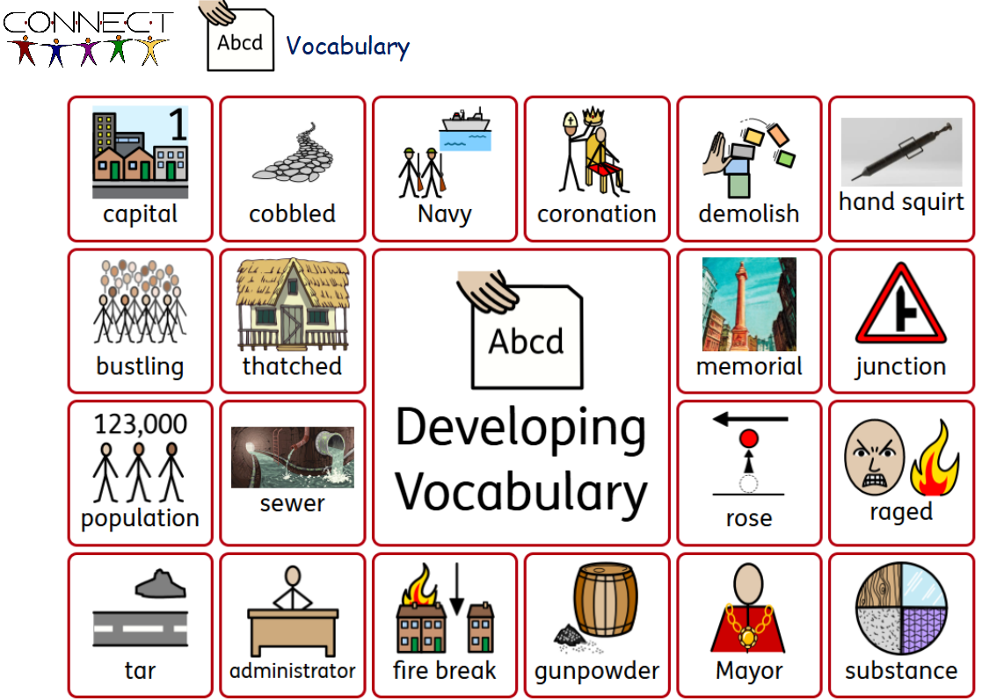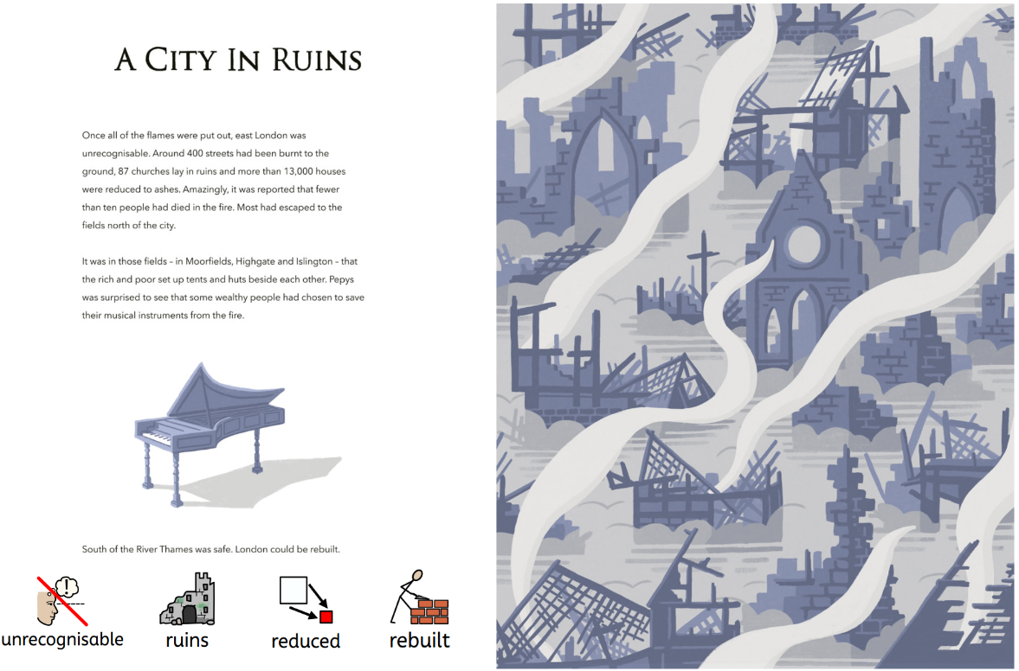
ELSEC and SALT support:
During 2024 – 2025, we were part of the ELSEC pilot study for Telford and Wrekin allowing us to continue to develop our understanding and implementation of speech and language support. During this process, we accessed Talkboost training and coaching for 2 Tas and had an ELSEC mentor in school regularly supporting our work. We were assigned a SALT professional to check our progress and provide training for Concept Cat which we plan to deliver in our new nursery that opens in September 2025.
During this process, we received two communication audits of Reception and year 1, identifying positive points and next steps to support our communication environment. From this, we organised Makaton training to support our sign work for staff in Reception and KS1. We also implemented tools into our newly developed SEND provision.
Extract from feedback:
“I also wanted to say how lovely your hub offer is and how the children we saw clearly love being part of it. The range of communication strategies you are using is varied, meaning that you are taking all the best bits from the audits and adding them to your own strategies:
- Makaton
- Boards celebrating children’s work and efforts in whatever they do
- Choice boards that use Widgit
- Snack time boards to develop vocabulary eg. Sour, juicy
- Sentence building activities with a choice of content.
It is all so wonderfully inclusive, especially for your pupil who is mostly non-verbal. In a world where there seems to be an ever-increasing number of complex children walking through our doors.
ELSEC Education Lead”
Data:
Talkboost programme: all pupils in Reception and Year 1 were assessed
Reception pupils 2024 – 2025: 9/11 PPG pupils required Talkboost. 7/9 (78%) progressed from amber to green and completed the programme successfully.
2/9 (22%) made progressed in the amber band but stayed in amber. These two pupils will be re-tested in year 1 next year to see if KS1 talkboost is required.
Year 1 pupils 2024 – 2025: 7/10 PPG pupils required Talkboost. 6/7 (86%) progressed from amber to green and completed the programme. 1 pupil remained red (EHCP pupil).
Narrative SALT programme: 1 PPG pupil in Reception accessed the narrative intervention due to being too low for Talkboost. He made good progress through the intervention and successfully completed 100% of the programme which assessed his use of vocabulary, grammatical structures, storytelling and narrative skills.
Next year, we plan to utilise one of our trained Tas to continue the offer of Talkboost. We plan to introduce Concept Cat into our new nursery and develop an ‘Inclusion and Well-being council’ made up of KS2 pupils who will lead on developing our use of Makaton across the school and at home for our families.
Challenge 5: Many of our pupil premium children require emotional health and well-being support due to difficulties outside school that then impact on their progress and attainment in school.
Intended outcome: To achieve and sustain improved wellbeing for all pupils in our school, particularly our disadvantaged pupils.
Many of our pupil premium children require emotional health and well-being support due to difficulties outside school that then impact on their progress and attainment in school.
Qualitative data and observations indicated that wellbeing and mental health is still significantly impacted, with a particularly marked increase in pupil anxiety. We used pupil premium funding to provide wellbeing support for pupils, and targeted interventions where required.
Support included a new Soft Start club running from 8:30 – 9:00, well-being check-ins, 1:1 ELSA sessions, Early Help support and support through Child in Need core groups. 3 pupils had funded places in Rocksteady and 86% attended after school clubs. 7 PPG pupils (3 SEND) also accessed Telford and Wrekin private music lessons for guitar and keyboard. In 2024 – 2025, we had 16 pupils access private music lessons with T&W music services, 44% of those pupils were PPG.
End of year data 2024 – 2025:
3 PPG pupils (also SEN) accessed ASD well-being toolkit for girls. 3 PPG pupils (also SEN) accessed soft start club. 4 PPG pupils (3 with SEND) accessed additional lunchtime support twice a week with the SENDCo. 8 PPG pupils (3 SEN) accessed ELSA sessions over the year.

Externally provided programmes
Please include the names of any non-DfE programmes that you used your pupil premium (or recovery premium) to fund in the previous academic year.
Programme | Provider
Picture News | Picture News Ltd.  Unit 3, Black Swan Yard  Belle Vue Terrace  Ripon  HG4 2QS

Further information (optional)
During 2025 – 2026, we are participating in research-based projects as we continually aim to enhance our school provision.
Year 1:
Project:
The OTTO Club, a programme which aims to improve children’s motor and handwriting skills, developed by a team of Occupational Therapists.
Year 5:
Project 1:
Selected as the control group for a trial on lesson planning using the AI lesson assistant, Aila. Supported by NFER and affiliated with Education Endowment Foundation and National Oak Academy.
Project 2:
Rehearsal Room Writing – trial (Royal Shakespeare company)
Trial to test the impact of training teachers to use rehearsal room strategies to improve Year 5 pupils’ writing ability. Rehearsal room strategies, designed by the Royal Shakespeare Company, employ Shakespeare texts to work with pupils through active, communal and oracy focused activities. This is a whole-class programme which aims to improve pupils’ writing through using rehearsal room techniques that actively engages with the stories and language of Shakespeare’s plays. Teachers will be trained to use these and integrate them within their own English schemes of work. In the rehearsal room lessons, pupils work collaboratively in groups to engage with the world, story, characters and language of the play(s). They might use games, freeze frames, soundscapes, character profiles, pictures and choral readings as active ways of working with the Shakespearean content, leading to a variety of writing outputs.
Our year 5 teachers will attend three separate sets of training (five days in total) with the RSC in Stratford-Upon-Avon, across the autumn and spring terms. We will then deliver at least 20 hours of lessons using rehearsal room techniques between November 2025 and June 2026.
Programmes that use talk, high-quality reading materials and drama activities show promise for improving outcomes in writing. The RSC’s own research ​‘Time to Act’ suggested that Rehearsal Room Writing had a positive impact on pupils’ writing outcomes.
During 2025 - 2026, we will launch a new Inclusion and Wellbeing council that will lead on the implementation of Zones of Regulation to support children’s ability to recognise, understand and know how to respond to their emotions.
In addition, 20 staff members will receive intensive training in Theraplay in January 2026 to support staffs understanding of this attachment-based therapy to help continue to strengthen relationships through fun, interactive play. Our hope is that this will continue to enhance emotional regulation and behaviour, strengthen social skills, and cognitive gains and support our trauma-informed approach embedded within school life.

